# DNS LOOKUP

A DNS lookup is the process of finding the IP address associated with a domain name.

DNS Information gathered : IP address ,A ,AAAA ,MX ,CNAME ,SOA ,NS ,TXT ,PRT

**TOOLS FOR DNS LOOKUP:** Dig,nslookup,host,Maxtoolbox,DNSstuff&Google public Dns

**Dig Tool :**

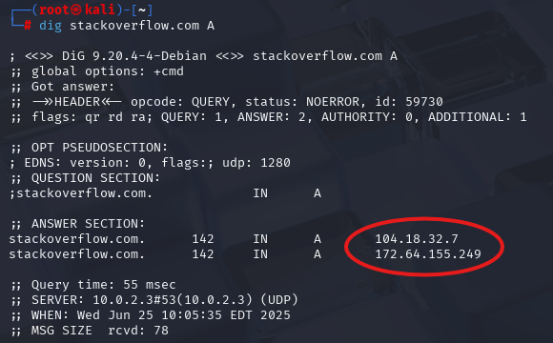

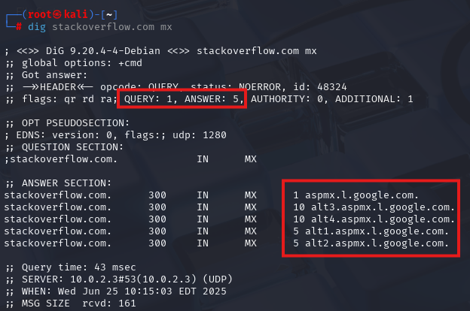

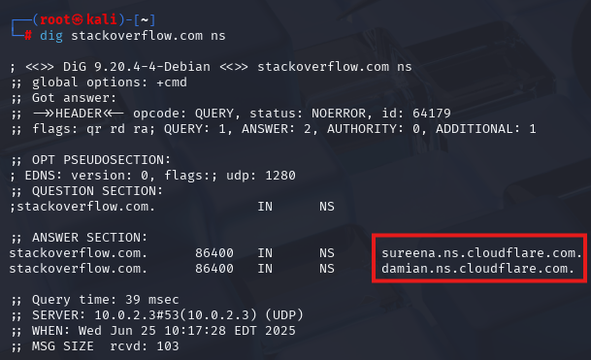

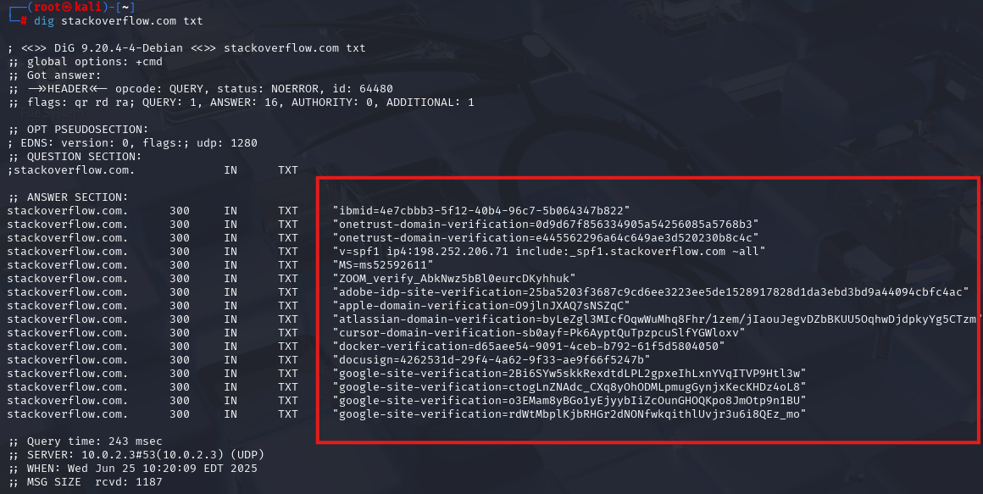

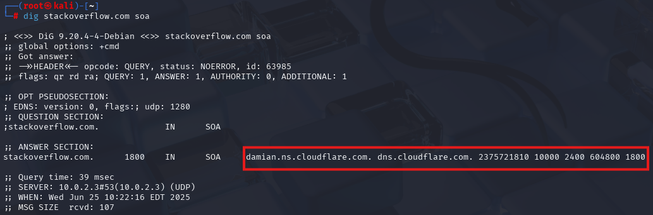

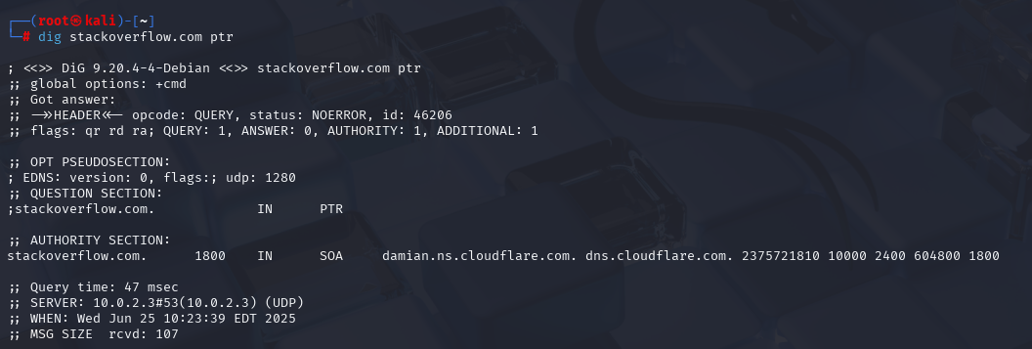

**Host Tool :**

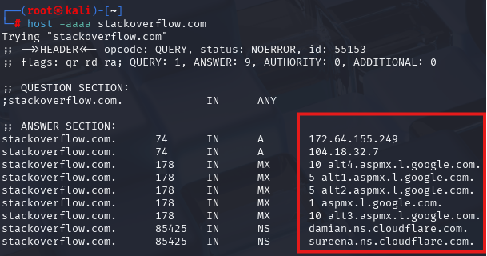

**MXToolBOX :**

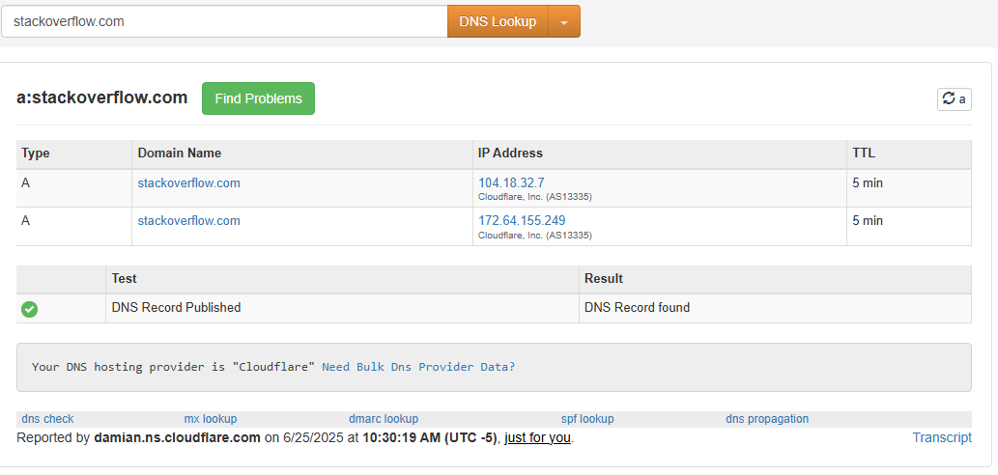

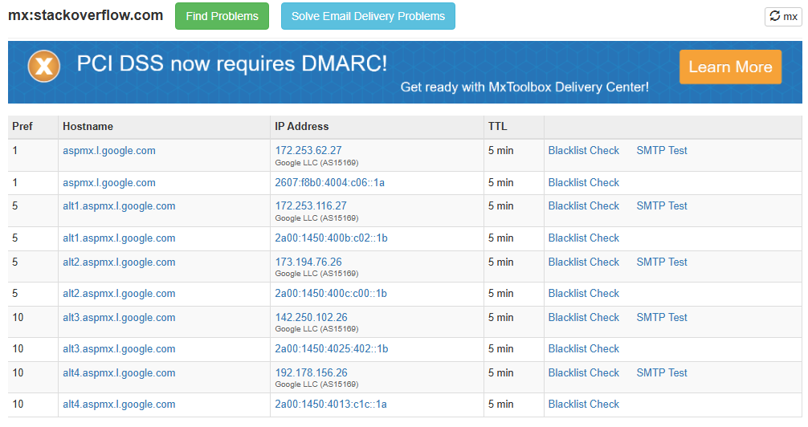

**Google DNS TOOL :**

